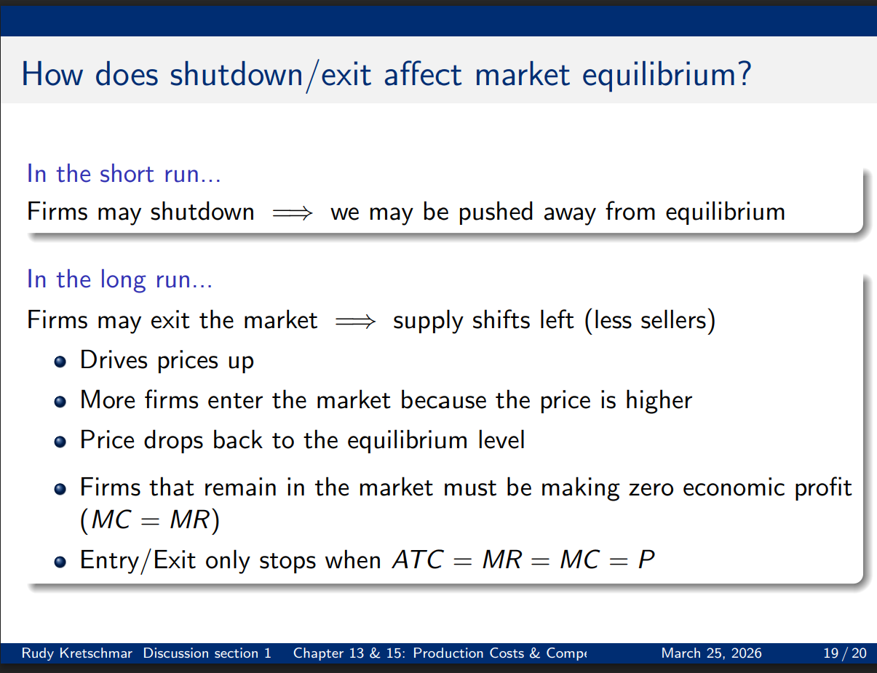

During class I said that the line “Forms that remain in the market must be making 0 economic profit” was wrong. This is erroneous.
Begin with the assumption that all firms face the same cost curves, and entry and exit is free.
In the long run, firms make zero economic profit because of free entry and exit in a perfectly competitive market.
If firms earn positive economic profit ($P>ATC$), new firms enter to capture those profits. Their entry increases supply, pushing the market price down. If firms incur losses ($P<ATC$), some exit, reducing supply and driving the price up. This adjustment continues until no firm wants to enter or exit — that is, until $P=ATC$. At this point, all firms earn zero economic profit.
The underlying assumption is free entry and exit with identical cost conditions: any firm can join or leave without barriers, and all face the same technology and input prices. This mechanism ensures that abnormal profits (above opportunity cost) are competed away, leaving each firm just covering all its costs, including the implicit cost of the firm’s time and capital.

Example for intuition
Imagine the local coffee market:
- If coffee shops start earning big profits, more entrepreneurs open coffee shops.
- More shops mean competition drives prices down until each owner earns just enough to cover rent, supplies, and a normal return on invested money.
- If prices fall too much, some shops close, reducing supply and nudging prices back up.
At equilibrium, the market settles where each shop’s owner is just indifferent between staying open or doing something else — earning “normal” returns but no extra profit.

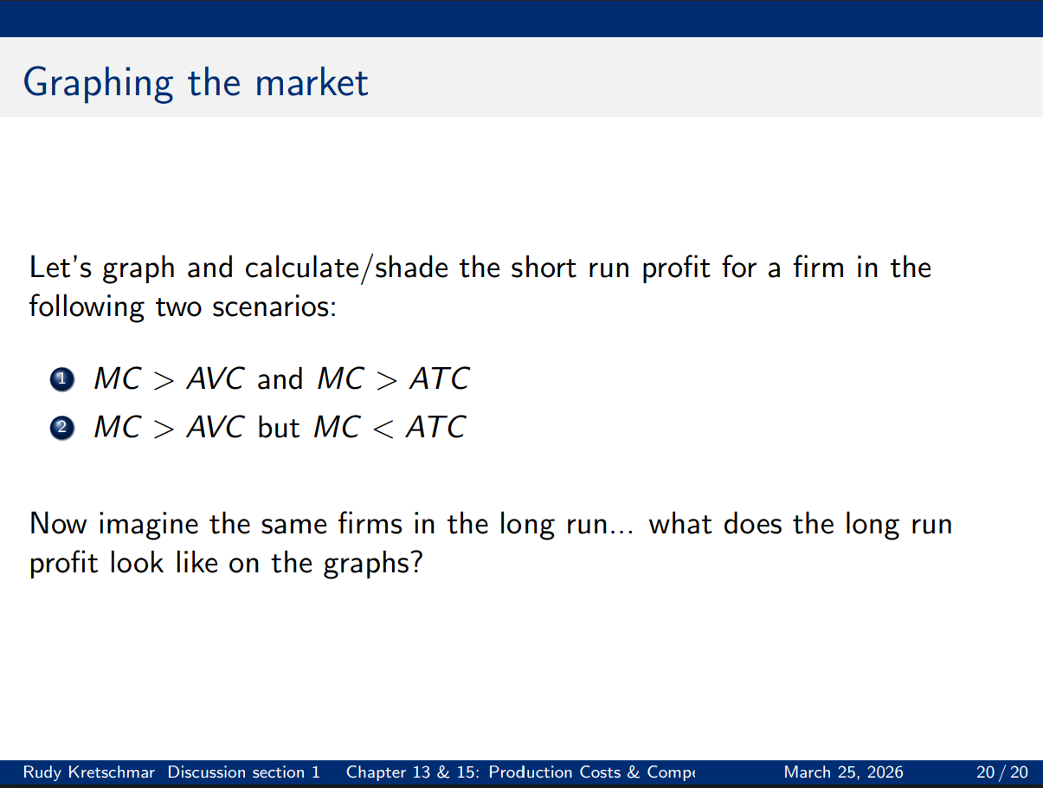
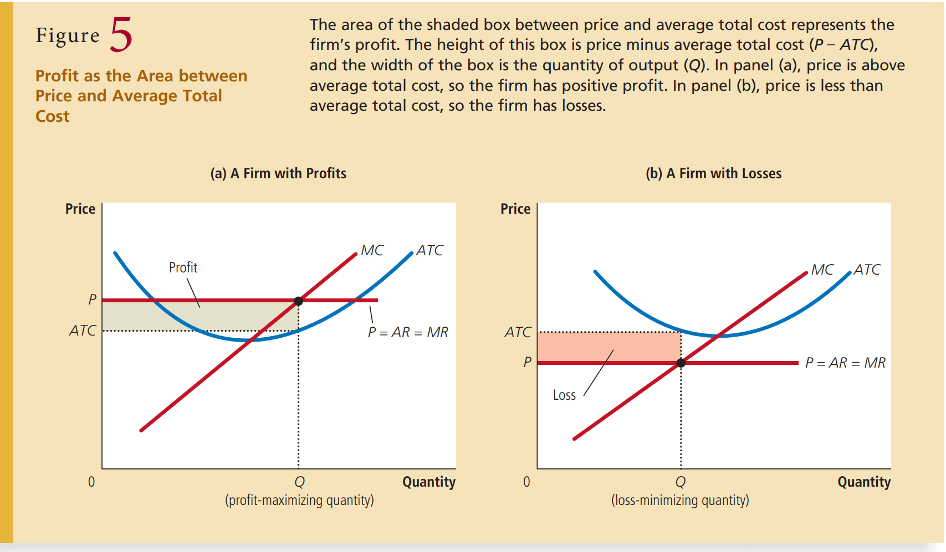

Graphing Short run loss. I drew this incorrectly in class. Short run profit should be drawn as the difference between the market price and the Average Total Cost, rather than the average variable cost. Hence, the figure I drew in your notes may not be correct. Figure 5 is in your textbook and graphs it correctly. To visualize this with average variable cost, you can draw in the curve under the average total cost. Moreover, the lines differ at the start by the value of the fixed cost, and converge as Q goes to infinity. For example, see below:
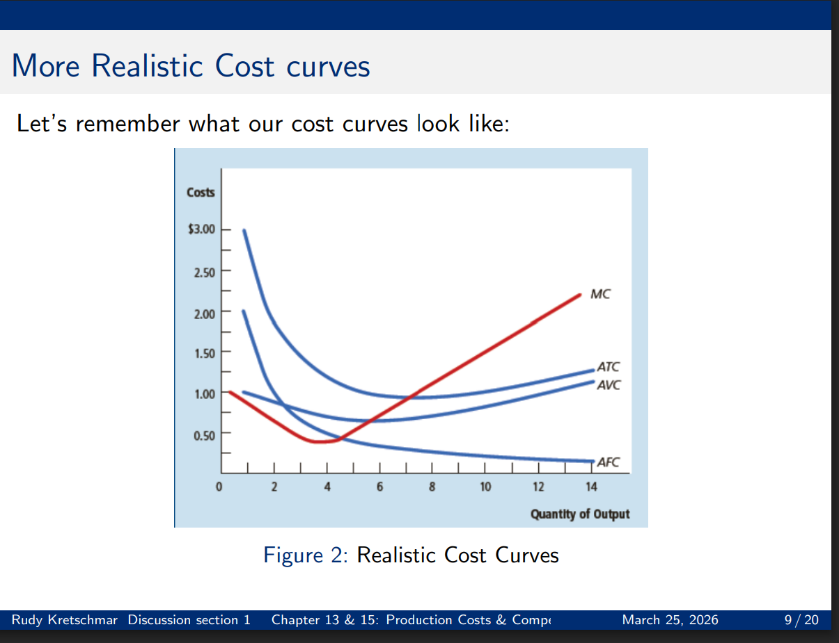
The important thing is that the loss or profit, depending on the market price, is the difference between the market price and ATC at the equilibrium quantity. Reach out to me if you have any questions.

